Software development lifecycle (SDLC)

List
Feasibility
Requirements
Analysis
Implementation
Testing
Deploy (Releasing the app)
Evaluation

Methodologies List
Waterfall, doing Everything start to finish in order
Everyone knows what their task is and sticks to it
Rapid application development, Creating Prototypes
Spiral, Risk focussed, unfixed process incorporating other methods.
Agile, Iterative method, like RAD, Allows shifting priorities in development
EXTREME PROGRAMMING, literally it’s just the power of friendship
It`s also agile
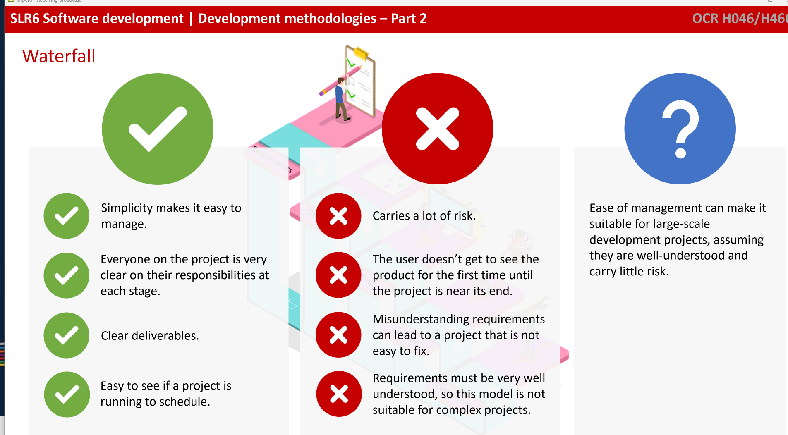
Waterfall
Adv
Simple
Everyone knows what their task is and sticks to it
Good for schedules
Disadv
VERY risky, misunderstandings cause a lot of issues
User can’t see product until near the end, which isn’t fun

Usage
Large scale projects when there is no risk
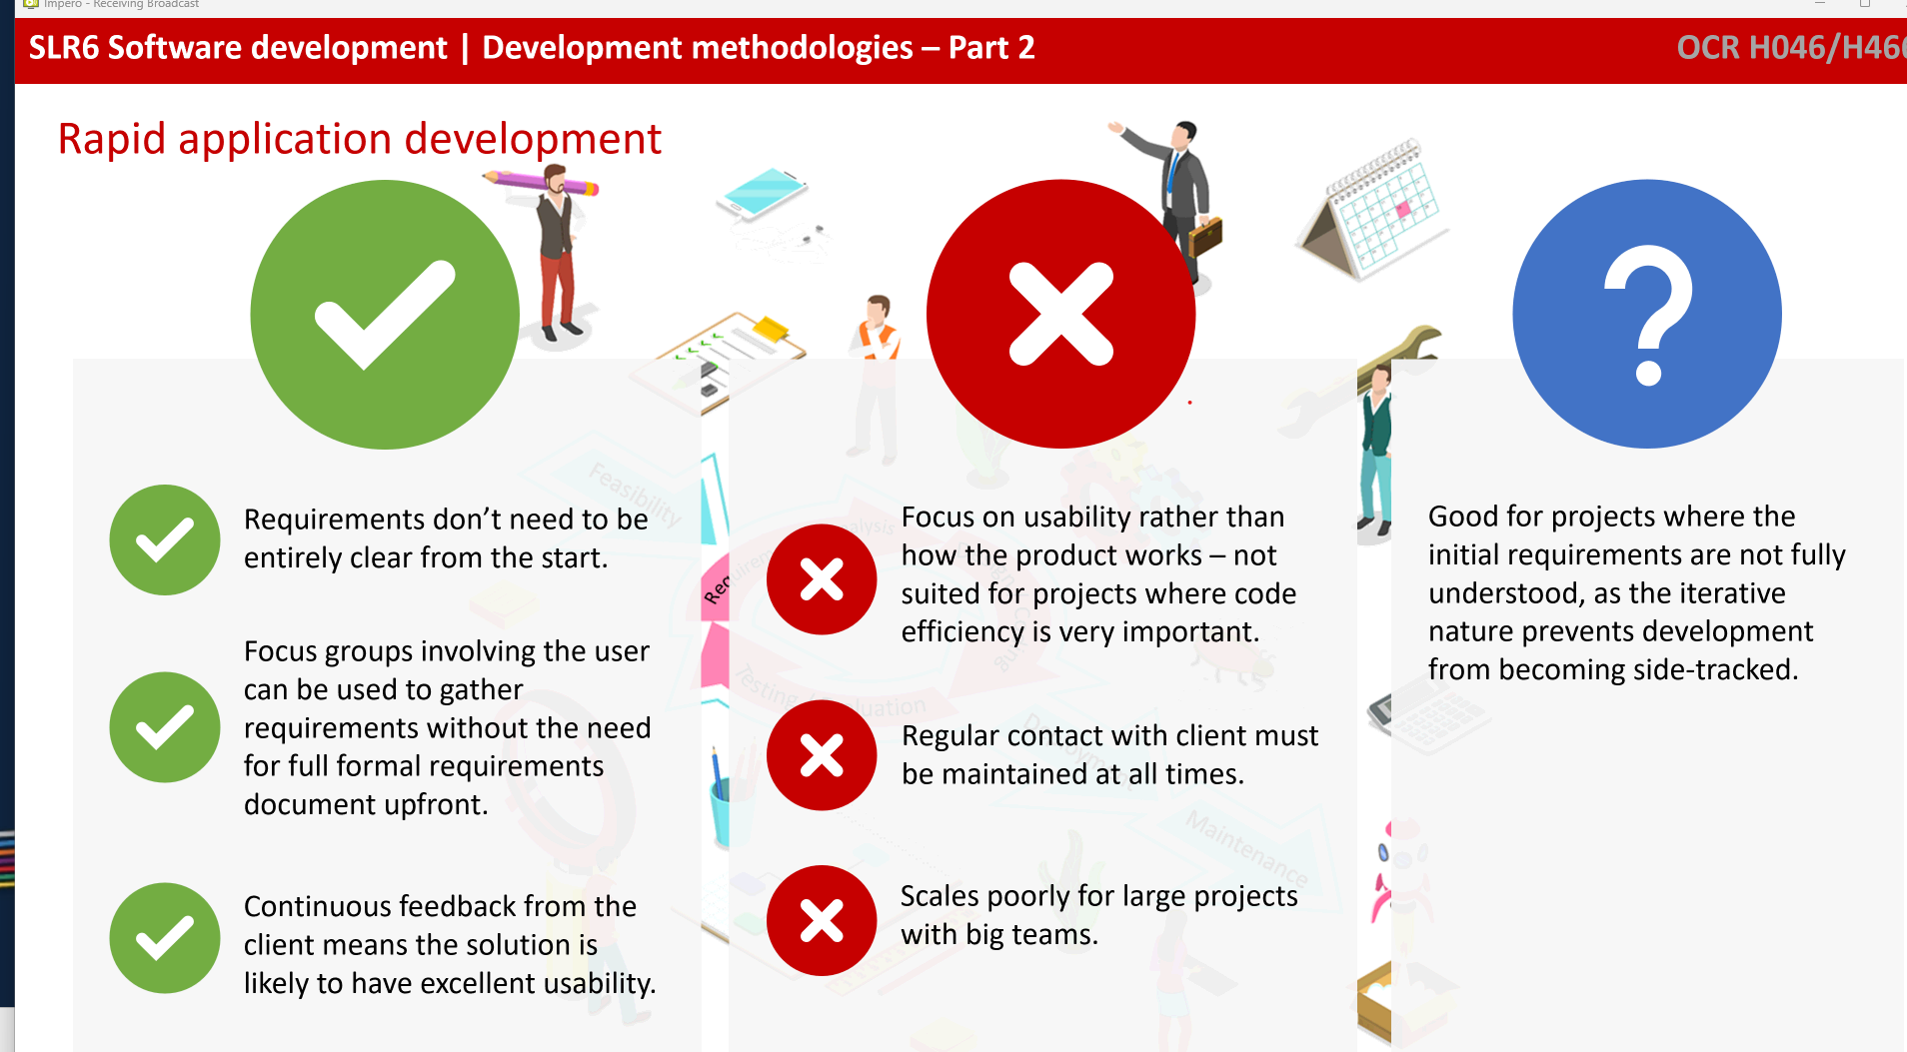
Adv
Requirements don’t need to be clear from the start
Continuous feedback from client makes it better for them

Disadv
Focusses on client happiness, so efficient code isn’t prioritised
Regular contact needed with client
Horrific for largescale projects

Usage
Small projects
Where the initial idea isn’t fully understood
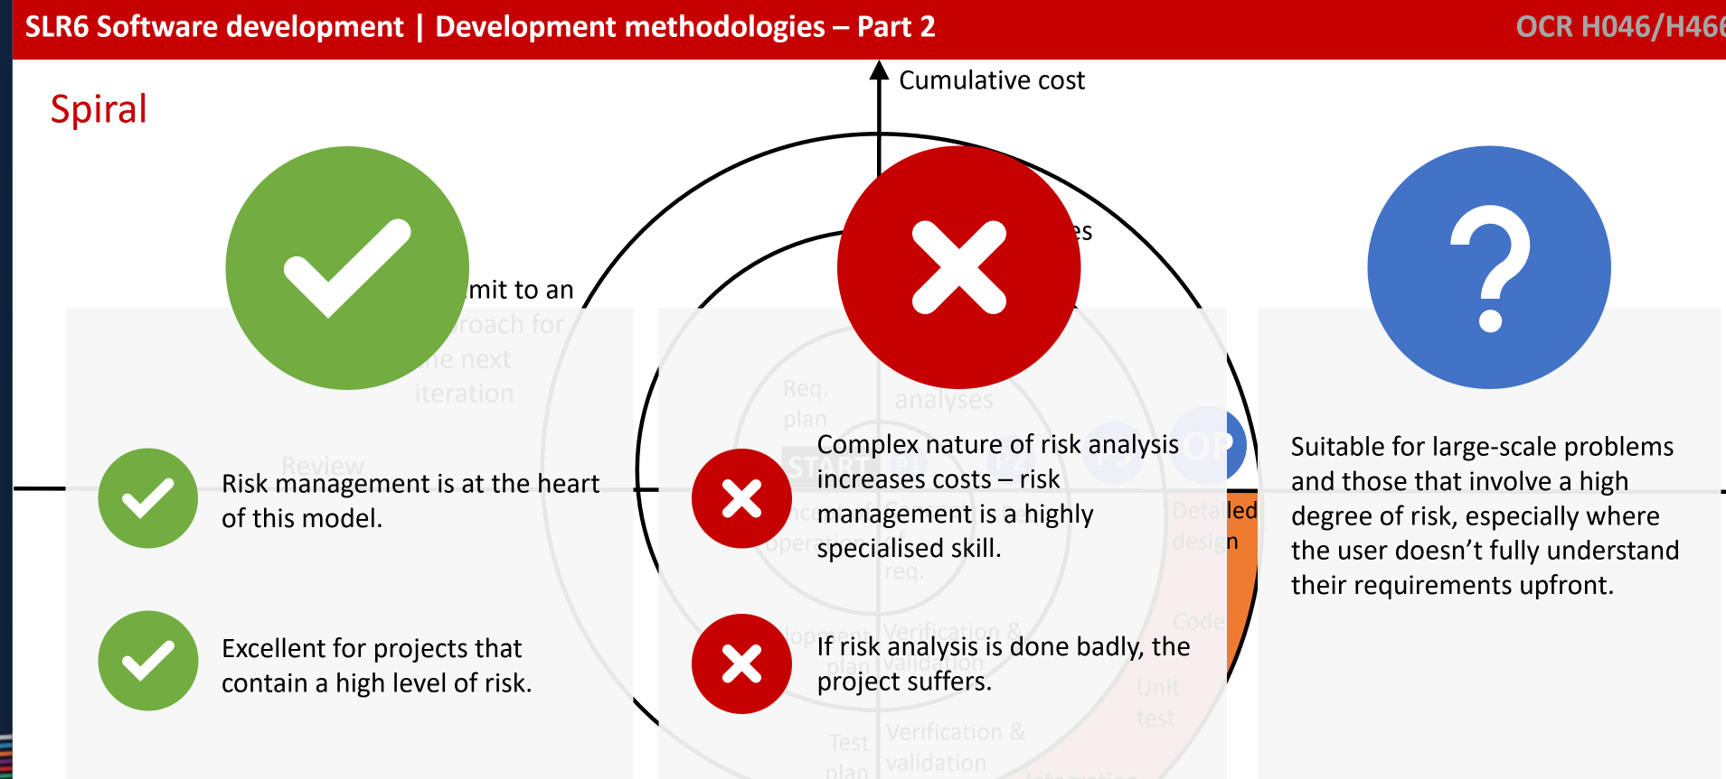

Adv
Risk management is good

Disadv
COST INNEFECTIVE LETS GO

Usage
Large scale problems
That carry risk
Also when initial ideas aren’t fully understood like RAD

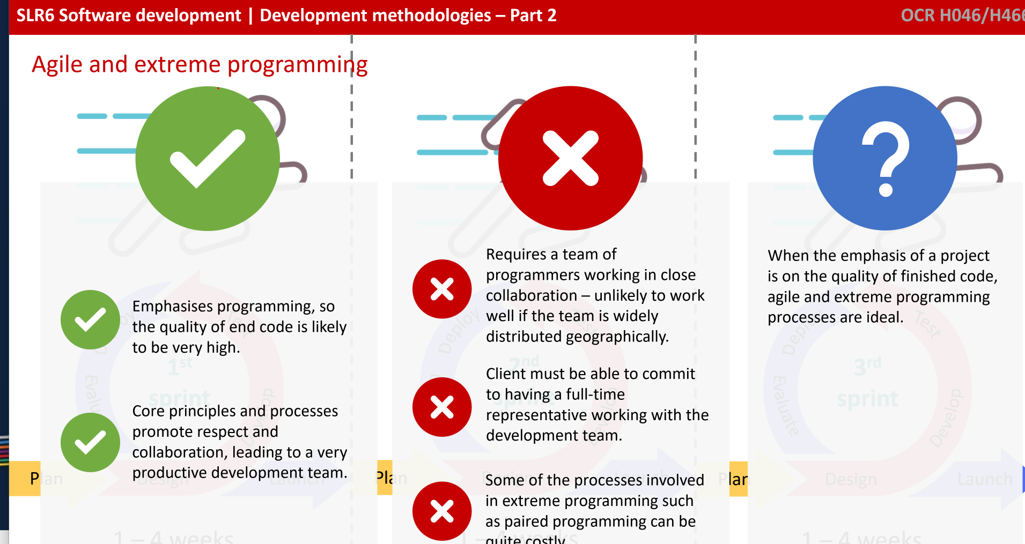
Adv
Quality of code is gonna be amazing
Lots of collaboration

Disadv
Requires a team for programmers all in one building
High committal
CAN BE COSTLY LETS GO WE FOUND IT

Usage
When you really want quality

FLOWCHARTS
Rounded square = Start/end (Terminal)
Diamond = Decision
Parallelogram = Input/output

